**CMSC 203 - CRN 20932**

**Name: Abigail Dulay**

**Instructor: Ahmed Tarek**

**Assignment 6 Documentation**

**UML Diagram -**

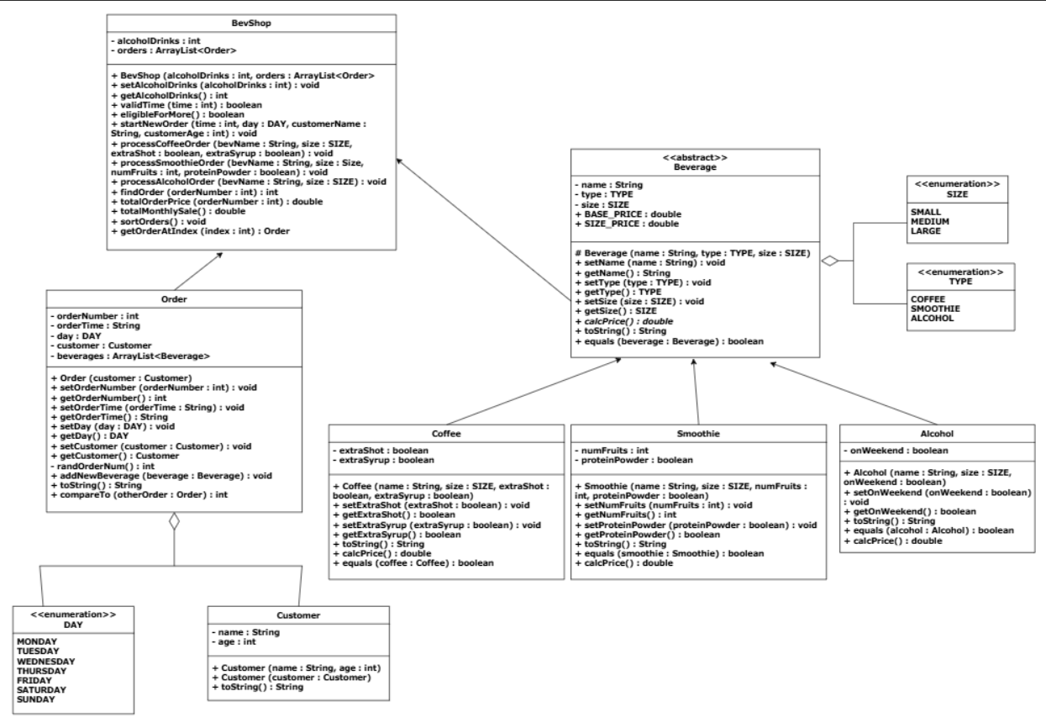

**Output —--------------------------------------------------------------------------------------------------------**

* **Output from BevShopNoGUITest**

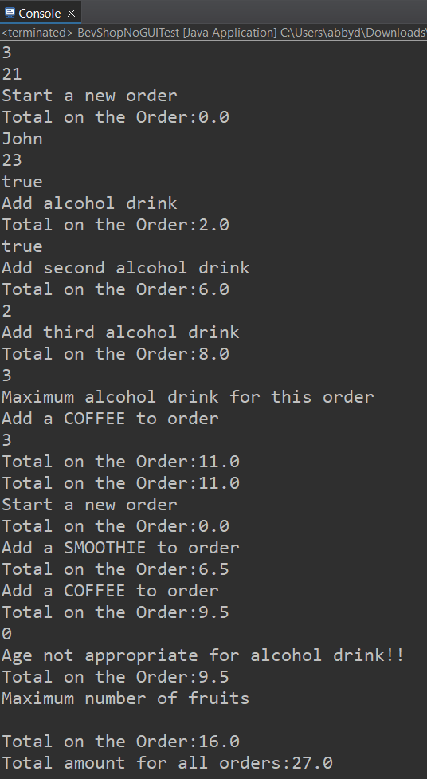

**JUnit Testing —------------------------------------------------------------------------------------------------**

* **Coffee, Smoothie, and Alcohol Tests**

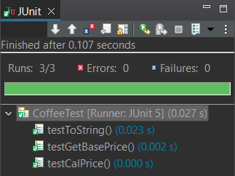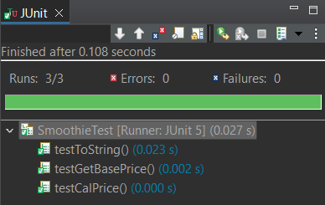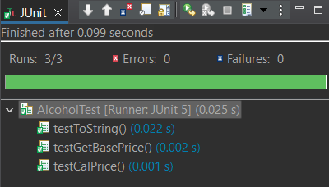

* **Order, Customer and BevShop Tests**

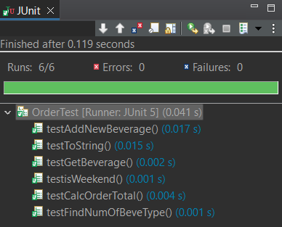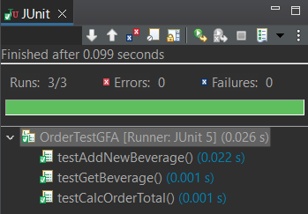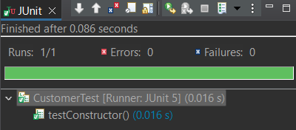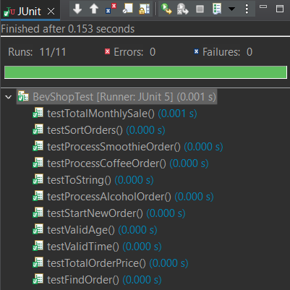

**Lessons Learned —-------------------------------------------------------------------------------------------**

1. **Write about your learning experience from working on this project.**

This project was a good test of skills for implementing various classes, methods, and working with interfaces and abstract classes. This project worked a lot with manipulating and creating Array Lists of various objects. Overall, this was actually quite a fun assignment despite being lengthy and was pretty straight forward.

1. **What have you learned?**

I learned a lot more about implementing abstract class methods, using interfaces, working with enum types, and also working with array lists. Making sure that objects and the array lists were properly manipulated was also important. Remembering to use shallow copies of objects when being returned from a function was a key factor when making changes/adding orders or beverages to the lists.

1. **What did you struggle with?**

I did not struggle so much with this assignment, rather it was just quite lengthy. Overall, the methods for each class were fairly simple and self-explanatory.

1. **What would you do differently on your next project?**

If I had more knowledge in JavaFX, I would definitely try to implement a user interface for this application to make it more immersive and applicable. Creating a user interface for this software would also be a good general practice in skill and practicality of use.

1. **What parts of this assignment were you successful with, and what parts (if any) were you not successful with?**

I was successful with all parts of the assignment and actually found it quite fun going through and implementing the code for each class and their methods.